# Workshop: Blog

This document defines a complete walkthrough of creating a **Blog** application with the custom MVC Framework and TomEE application server.

# What Will You Create

In the end of the whole tutorial, you should have blog which supports the following functionality:

* **Register** and **Login Users**
* **Create**, **Update**, **Read** and **Delete** **Articles**
* **Responsive Design** using **Bootstrap**
* **More…**

Pictures:

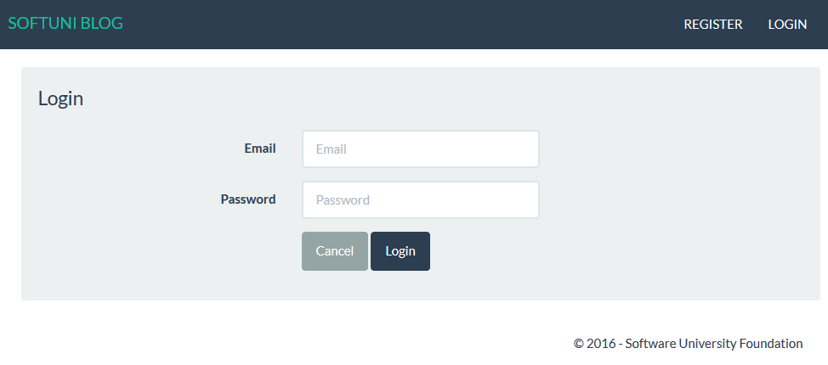

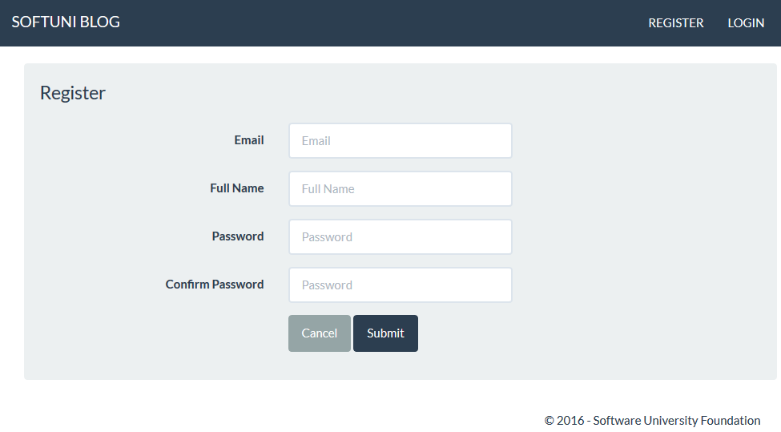

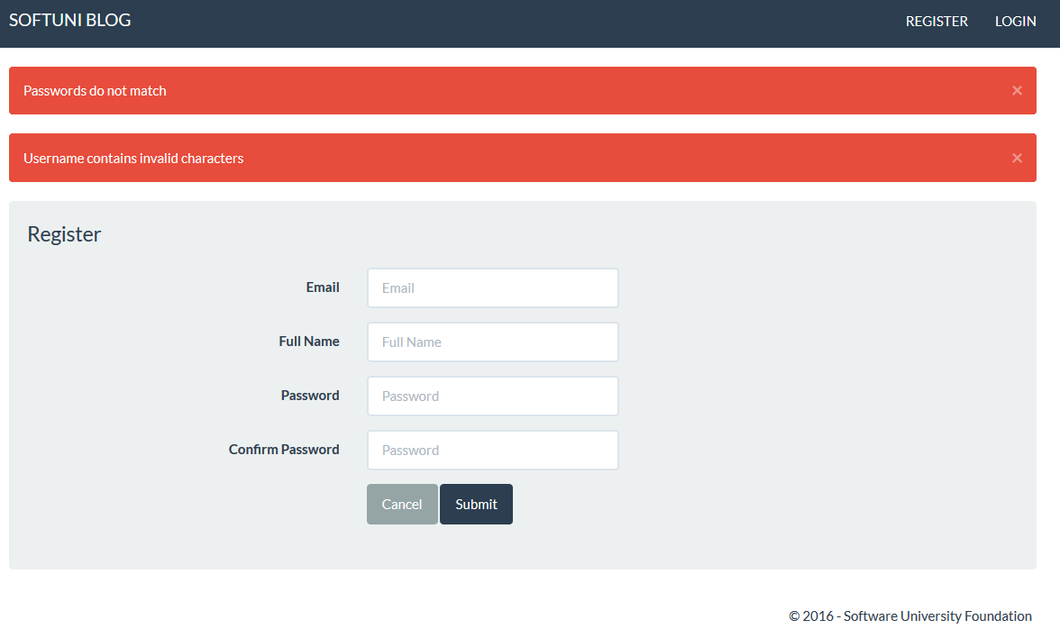

# Creating Register and Login

Today in the **first part**, you will only create the **user registration** and **login**.

## User Register

You are given a skeleton, containing templating system. There are TODO tags in some of the files, so you better get familiar with the project. You are given an example form called register.jsp for the user registration. Create a new UserController. You need to implement the methods for GET and POST request for user registration. You need to create connection with Hibernate and create Model, Repository and eventually a Service layer. The **user model** should contain the following fields:

* Id – Identity
* Full name – min length – 5, max length – 50 and, only containing English alphabet characters
* Email – unique, not null
* Password – not null, min length – 3, max length – 30

When registering a new user, you should have the following **validations**:

* The Password and the Confirm-Password values should be equal
* The Length of the password should be correct
* The Email must contain "**@**" and "**.**"
* The Name should have the correct length

If there are any errors in the form, they should be passed to the view. The notifications are handled in the error.jsp file, so you only need to **include it in your view**. It's **important** that your error collection is called errors.

## User Login

Using the register form as a template, **create a login form**, that looks like in the pictures above. You should create the routings **handling** the **GET** and **POST** **requests**. On successful login, you should **save the user id** in the **session storage**.

In the next chapters, we are going to add the article functionality. ☺